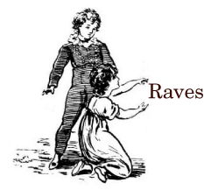
“I can’t get enough of this great site.”
- Justin Kaufmann, of Chicago’s Schadenfreude comedy troupe

“Excellent. I just set my time to Flavor Flav and dressed the way the Monkey would have me.”
- Robb Montgomery, international newspaper consultant and CEO of VisualEditors.com

“It looks alcoholic.”
- Patric King, designer (Gawker Media, Radar Magazine Online, and PBS’s MediaShift)

“If Rhodes had a publicist, she would probably have talked him into one of the more descriptive titles he was mulling, like Chicago Review or some such, rather than naming it after his favorite bar . . . already the most literary and winningly whimsical of Chicago news sites."
- Steve Johnson, Chicago Tribune

“A valuable community resource.”
- Carol Marin, Chicago Tonight

“I read it semi-religiously.”
- Joel Weisman, Chicago Tonight:Week in Review

“No morning would be complete without The Beachwood Reporter, and Steve Rhodes' amazing ability to find the good parts of the morning papers so we don't have to.”
- Harold Henderson, Chicago Reader

“The Beachwood Reporter is what Colicky Baby Records and Tapes would be if I had any talent, energy, or work ethic.”
- Pete Moss, Colicky Baby Records and Tapes

“Most regular people are able to just avoid reading stuff that doesn't interest them, but Rhodes is a Very Important Media Critic, and, as is often the case for under-recognized geniuses, he must suffer for his art.”
- Debra Pickett, former Chicago Sun-Times columnist

- Appearances by Rhodes on CNN’s Reliable Sources, WTTW’s Chicago Tonight, Chicago Public Radio’s 848 public affairs show, WGN-AM’s Spike O’Dell Show.

- Featured on two panels at the national convention of the Society of Professional Journalists.

- Featured in The American Editor as “Tips From Eight of the Best . . . “

- Numerous newspaper citations from the Los Angeles Times to the Toronto Globe and Mail and points in-between.

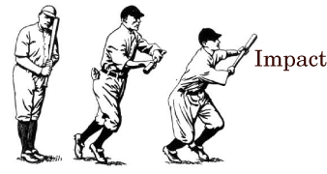
- Two finalists for the local Lisagor Awards, including one for our “Barista!” series.

- One of media maven Jim Romenesko’s Media People and frequent links on his site, the media industry’s premiere gathering place.

- Frequent links and mentions from the Tribune’s Eric Zorn, Steve Johnson, and Steve Rosenbloom.

- Frequently quoted in the Sun-Times’s Controversy section and on Elliot Harris’s sports page.

- Rhodes asked to sit on <em>Print</em> magazine blogging panel.

- More than 45,000 “absolute unique visitors” in August 2007 according to Google Analytics.

- Parody songs played on Chicago radio stations WXRT-FM, WMVP-AM, and WZZN-FM.

- Open Letter columnist Cate Plys regularly featured on Chicago Public Radio.

- Readership includes state Rep. John Fritchey and Lake County Coroner Richard Keller.

- Asked to provide the Illinois entry to the Campaign for the American Reader literacy project.

- Vocalo.org (Chicago Public Radio) produces audio versions of our Mystery Debate Theater.

- Links from national sites such as Daily Kos, Talking Points Memo, boing boing.

- Sportswriters Eric Emery and Marty Gangler frequently linked by Tribune, Sun-Times.

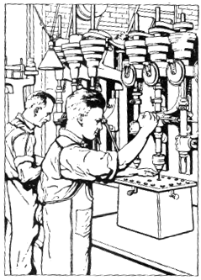
What is The Beachwood Reporter?

The Beachwood Reporter is an irreverent but journalistically serious Chicago-centric online newspaper. The daily attraction of the site is the front page media commentary and roundup called The Papers. The Beachwood’s media and political coverage has quickly recaptured Steve Rhodes’s former readership from six years as political and media writer for Chicago magazine, as well as his work for Newsweek and the Chicago Tribune before that.

The Beachwood is also making a mark with its unique cultural coverage in sections such as Music, TV, Books, Sports, and People Places & Things. In so doing, the Beachwood hopes to build a large audience by aggregating several smaller ones.

Throughout, the Beachwood’s tone is consistent; unabashed honesty and authenticity leavened with wit and insight, produced by veteran journalists with rigorous reporting standards.

(Our “About” page describes us this way: The Beachwood Reporter is an international news-gathering operation dedicated to the proposition that journalism and rock and roll done right are inextricably linked; that truth and comedy are two sides of different coins that, when rubbed together properly, can mutate into a slug that will efficiently disable a parking meter; and that while bad news travels fast, our news travels even faster.)

The Beachwood hopes in time to add new sections and features including a City section that can house our urban and investigative reporting as it comes to fruition. The Beachwood Media Company, which owns The Beachwood Reporter, hopes in time to add other already-conceived sites to the mix to create a stable of revenue-producing properties as a winning business strategy.

Who is The Beachwood Reporter?

Editor & Publisher: Steve Rhodes (Chicago Tribune, Newsweek, Chicago magazine)

Art Director: Cate Nolan (MLB.com; Ignite Sports Media; Chicago Tribune; site design for Island/Def Jam Records; Rodgers & Hammerstein; White Castle)

Features Editor: Natasha Julius (The Year of Living Girlishly; Tribune Media Services)

TV and Music Editor: Don Jacobson (Profits Journal; United Press International; Duluth News-Tribune)

Special Correspondent: Timothy Inklebarger (statehouse reporter, Juneau Empire; Associated Press)

Open Letter Editor: Cate Plys (Tribune; Sun-Times; Reader)

Special Affairs Editor: Tim Willette (Screaming at a Wall; Human Horsey)

The Commissioner: Scott Gordon (The Onion)

Football Affairs Editor: Eric Emery

TV Affairs Editor: Scott Buckner

Cinema: Marilyn Ferdinand (FerdyOnFilm)

Demographic Affairs Editor: Kiljoong Kim (sociologist, De Paul University)

Comedy Rewrite/Cubs: Marty Gangler (Sick/Personal Day, Second City; Self-Centered Girl, pH)

Poetry: J.J. Tindall

Barista!: Maude Perkins

Legal: Evan Brown (Hinshaw & Culbertson; InternetCases.com)

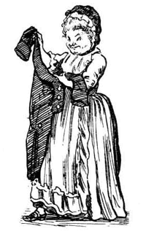
What Can The Beachwood Reporter do for you?

We will deliver your advertising message to a growing audience of news and culture junkies, civically-engaged readers who are passionate about their city and the world beyond. The New York Times calls them “Influentials.”

You will align yourself with the wit and wisdom of a site (and company) uniquely capable of sustaining its early buzz.

Ad Rates
We use IAB Standard ad sizes.

Rail Boxes – 180 x 150
$10 per 1,000 AdViews.

Section Home Boxes – 234 x 60
$10 per 1,000 AdViews.

Inside Page TV Boxes – 234 x 60
$20 per 1,000 AdViews.

Header Boxes Front Page and Inside
Negotiable

Alternate packages via monthly payments available.

Ad set-up: onetime $50 fee.

Ad creation/you keep: $250.

Ad creation/Beachwood only: $50.

Sponsorships available upon request.

For more information: Contact Steve Rhodes at (773) 235-8986 or at dusty@speakeasy.net.

